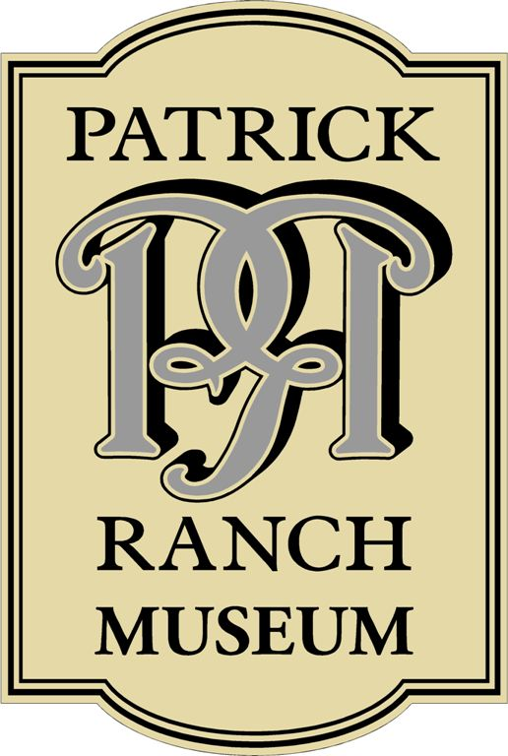
Patrick Ranch Museum
Volunteer Application Form

Name (please print) Date
Address City Zip
Home Phone Cell
Email Address Preferred method of contact
We value our volunteers and want to find a volunteer position that is right for you. Please look over the list of positions and jobs that are needed, and feel free to check all that you are interested. Keep in mind that not all positions may be available year round.
⃝ Cataloging and care of collections ⃝ Community Outreach/ Marketing
⃝ Fundraising ⃝ Gift Shop/Retail Sales
⃝ Research/History ⃝ Membership Development
⃝ Exhibits/Displays ⃝ Gardening
⃝ Children’s Activities ⃝ Assisting with special events
⃝ Museum Docent ⃝ Helping in the Cafe
⃝ Assisting with school field trips ⃝ Assisting with routine maintenance
I’d be willing to volunteer:
⃝ Weekly ⃝ Monthly ⃝ 1 - 4 times a year ⃝ As needed ⃝ Other
Please list any pertinent allergies or physical limitations:
Emergency Contact: Name: Phone:
If accepted as a volunteer, I agree to attend an orientation session and to adhere to all the policies and procedures of the Far West Heritage Association.
Signature: Date:
Return to: Far West Heritage Association, 10381 Midway, Durham, CA 95938

